Movie – Day of Wrath

Direction by - Carl Theodor Dreyer

Country - Denmark

Language- Danish

Cast- Thorkild Roose, Lisbeth Movin and Sigrid Neiiendam

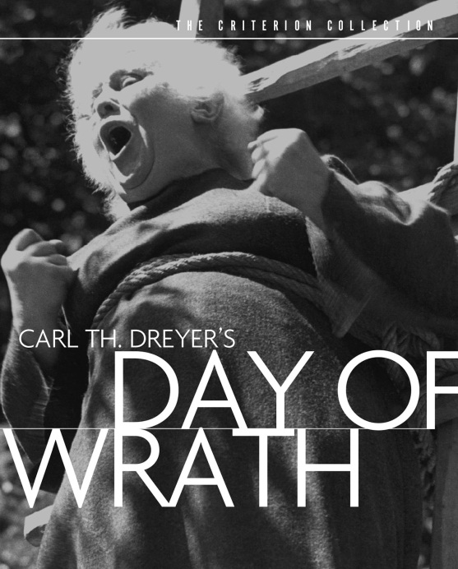

Its 17th century Denmark, a massive witch hunt is on. Some women are supposed to be possessing supernatural powers. The villagers believe that the minds of these women are ruled by the hideous Satan under the influence of which, they are accused of committing sins. On suspicion, these women are denounced as witches. They are arrested and asked to make a confession, either voluntarily or by afflicting torture. These women are then burnt alive as a punishment in the name of GOD. This horrifying scene of execution is witnessed by the village, the judges and the clergymen. A choir of young boys sings to God near the stake as the flesh of the accused smolders in the flames.

This is the kind of life the villagers here live- constantly tormented by fear. They suffer under strict social repression. The devout clergymen hold all the power. Absalon is a respectable pastor who lives with his wife Anna and his mother. He is a widower in his 50s who, after his wife’s death, has married Anna- a beautiful young woman much younger to him. He has never fulfilled Anna sexual desires. He is not a vile man and much later realizes Anna’s desperation. Absalon’s mother hates Anna and loves her son beyond everything.

Absalon’s young son Martin, from his previous wife comes to visit them. This kicks off the beginning of a tragic end. Martin and Anna fall in love with each and this conduct is completely against the strict moral code of the society. It’s sinful and scandalous. When Anna reveals her love for Martin to Abslon, it ends in Absalon’s death. Life takes a cruel turn and the results - you need to watch for yourself!

The torture and execution of Herlofs Marte is probably one of the most horrifying scenes I have witnessed in cinema. No visuals of actual torture are shown. Dreyer uses sounds to get the tormenting effect. One cannot escape, no matter how hard he tries the severely painful fear of death in the eyes of Herlofs Marte. The brutality of punishing someone by burning her at stake makes your soul shudder. The horror leaves you devastated. The movie reminds you of Carl Theodre Dryer’s another masterpiece- The Trial of Jaon of Arc.

For centuries, social repression has been so strong that a human mind’s rationality and sense of well-being crumbles under its weight. Minds are convoluted with blind faith. Demons of brutality and anarchy come closing in. Even mankind’s greatest asset, LOVE, fails to sustain.

The movie makes us wonder that- why in the name of GOD is individual freedom repressed? Can faith and morals be ever forced upon some one? The answer is very simple – NO. Then why do some minds fail to access true wisdom? And what is immoral to one man might be completely moral to another. Ethics can be universal but not values are subjective varying for person to person. We all have a right to choose our value system and even GOD cannot take that right away from us. But for how long will this conflict continue? And how many more victims before we find our way? The answer my friend is blowing in the wind….

